FLASH TOOL MANUAL

Note :- Ensure your ESP32 is connected to your computer via a USB programmer.
1. Open the Flash tool .

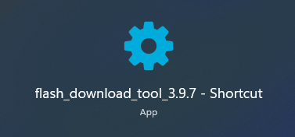

2. Configure Settings and press “ OK “ button.
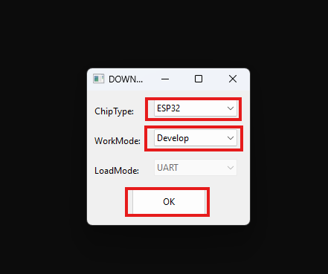

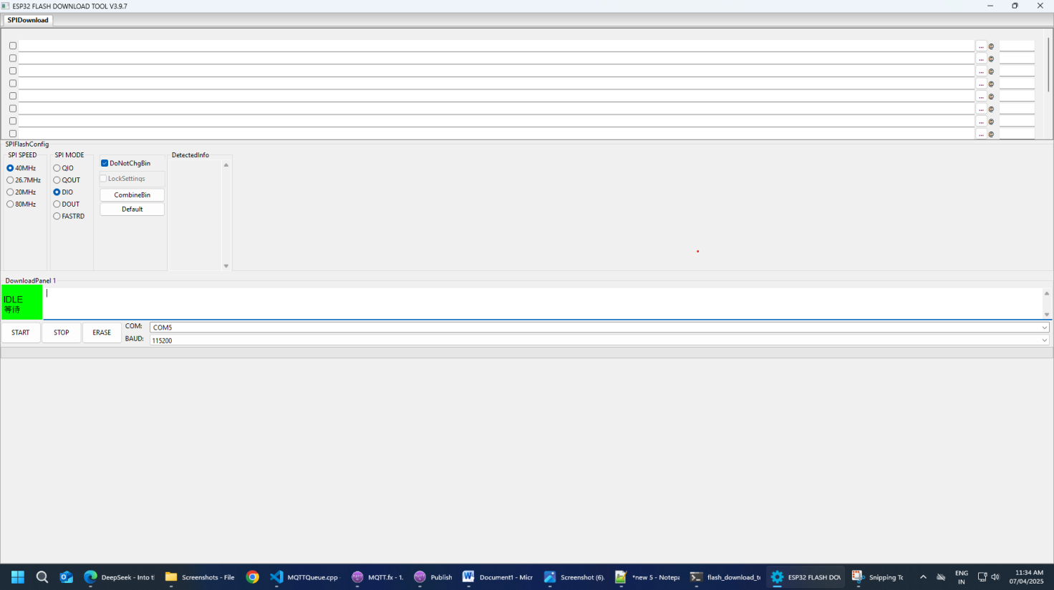
3. You will see new window.

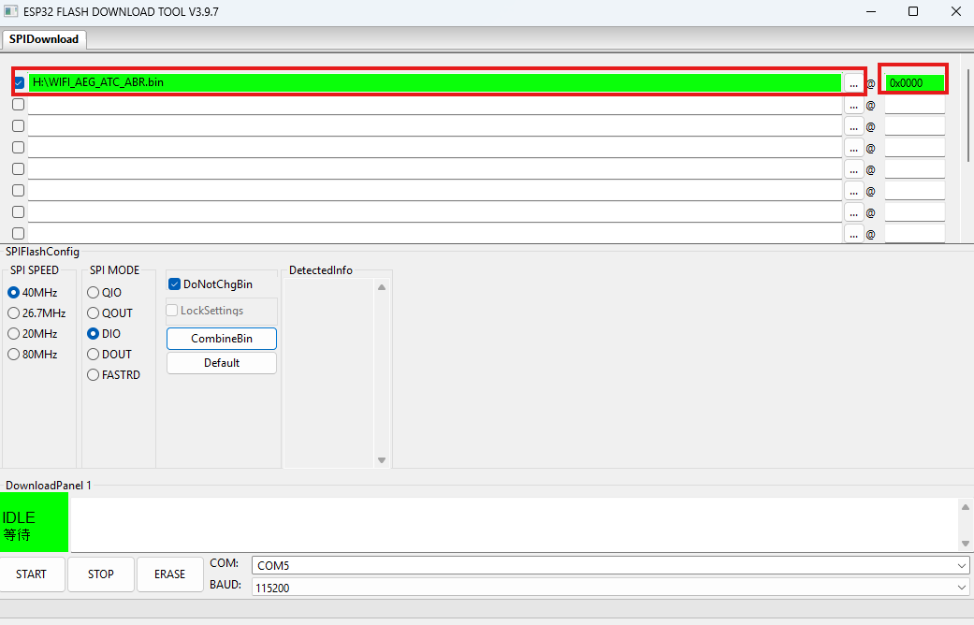
4. Provide path of bin file and write address “0x0000”.
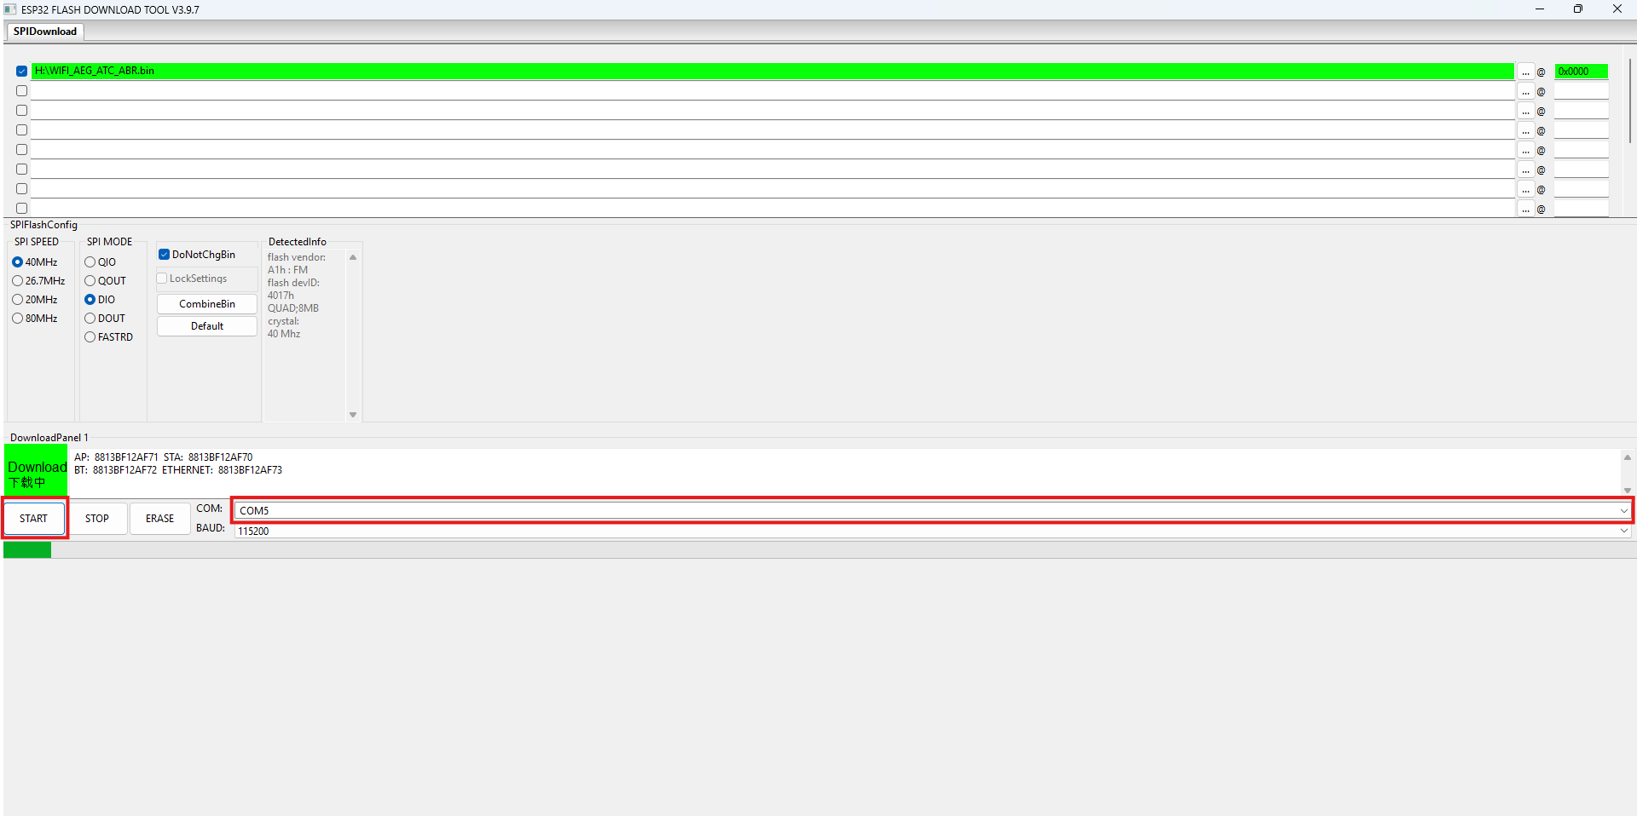
5 . Select COM port and baud rate (115200) then press the “START” button to begin the upload.

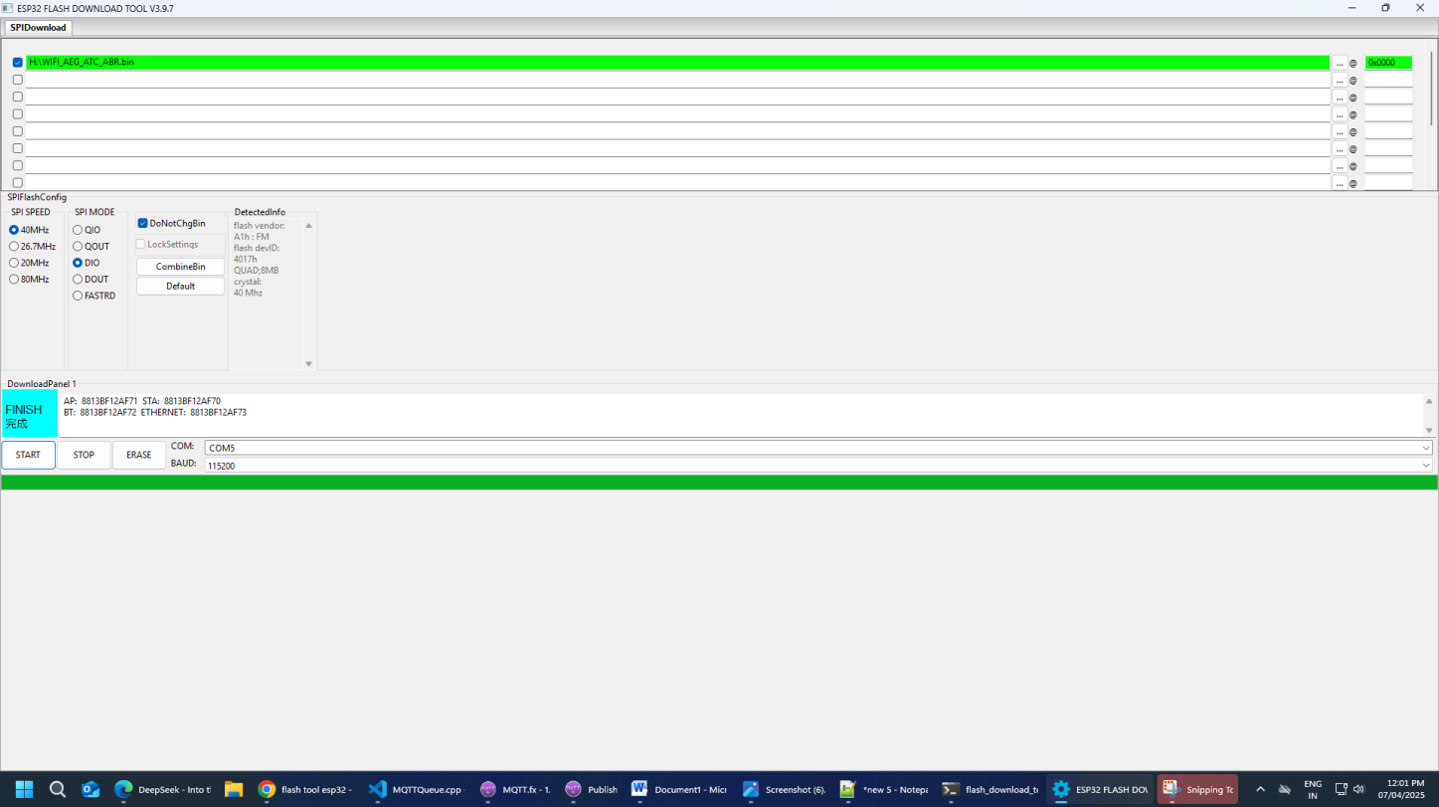
6 . Wait for the upload to Finish (you’ll see a success message). Restart the ESP32.

